Basic Terminology

Data structures are the building blocks of any program or the software. Choosing the appropriate data structure for a program is the most difficult task for a programmer. Following terminology is used as far as data structures are concerned

Data: Data can be defined as an elementary value or the collection of values, for example, student's name and its id are the data about the student.

Group Items: Data items which have subordinate data items are called Group item, for example, name of a student can have first name and the last name.
Record: Record can be defined as the collection of various data items, for example, if we talk about the student entity, then its name, address, course and marks can be grouped together to form the record for the student.
File: A File is a collection of various records of one type of entity, for example, if there are 60 employees in the class, then there will be 20 records in the related file where each record contains the data about each employee.
Attribute and Entity: An entity represents the class of certain objects. it contains various attributes. Each attribute represents the particular property of that entity.
Field: Field is a single elementary unit of information representing the attribute of an entity.

Need of Data Structures
As applications are getting complexed and amount of data is increasing day by day, there may arrise the following problems:
Processor speed: To handle very large amout of data, high speed processing is required, but as the data is growing day by day to the billions of files per entity, processor may fail to deal with that much amount of data.
Data Search: Consider an inventory size of 106 items in a store, If our application needs to search for a particular item, it needs to traverse 106 items every time, results in slowing down the search process.
Multiple requests: If thousands of users are searching the data simultaneously on a web server, then there are the chances that a very large server can be failed during that process
in order to solve the above problems, data structures are used. Data is organized to form a data structure in such a way that all items are not required to be searched and required data can be searched instantly

Data Structure Classification
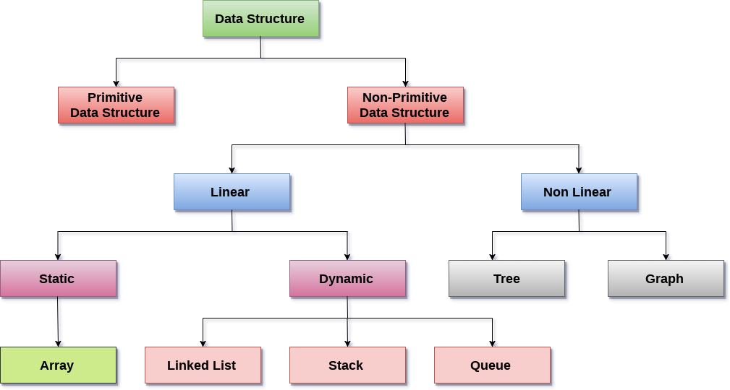

Data Structure is a way to store and organize data so that it can be used efficiently.

as Array, Pointer, Structure, Linked List, Stack, Queue, Graph, Searching, Sorting, Programs, etc.

Types of Data Structures

There are two types of data structures:
1. Primitive data structure
2. Non-primitive data structure

Primitive Data structure
The primitive data structures are primitive data types. The int, char, float, double, and pointer are the primitive data structures that can hold a single value.

Non-Primitive Data structure
The non-primitive data structure is divided into two types:
1. Linear data structure
2. Non-linear data structure

Linear Data Structure
The arrangement of data in a sequential manner is known as a linear data structure. The data structures used for this purpose are Arrays, Linked list, Stacks, and Queues. In these data structures, one element is connected to only one another element in a linear form.

Non linear Data structure
The data structure where data items are not organized sequentially is called non linear data structure.In non linear data structure one element is connected to the 'n' number of elements. Examples of non linear data structures are Trees and Graphs.

Data structures can also be classified as:
1. Static data structure: It is a type of data structure where the size is allocated at the compile time. Therefore, the maximum size is fixed. I.e array, stack, queue.
2. Dynamic data structure: It is a type of data structure where the size is allocated at the run time. Therefore, the maximum size is flexible. I.e linked list

Data structure Operations
– traversing
– inserting
– deleting
– sorting
– searching
– merging

Advantages of Data structures
– Allows easier processing of data.
– efficient processing of small as well as large amount of data
– It allows information stored on disk very efficiently
– necessary for designing an efficient algorithm.
– It is secure way of storage of data
– Reusability

Disadvantages:-
1) It is applicable only for advanced users.
2) If any issue occurs it can be solved only by experts.

https://www.javatpoint.com/data-structure-introduction

https://www.studytonight.com/data-structures/linked-list-vs-array

